**Daniel Williamson**

**Project #4**

**3/10/16**

**CS 200**

Project Overview

Purpose:

The purpose of this project was to have a user input a floating point number and use that said floating point number to create and print a bit-level analysis of the number.

Approach:

To begin this project, I immediately went to the internet to gain an understanding of how to program on a basic level in C++. After I read up on it, I began to plan how the program should run. I decided to simply keep everything in the main method as my C++ abilities are not that impressive. I started by defining my namespace and what to include. As I began coding, I realized it would be easier to have an error method that I could call whenever an error would occur so I didn’t have to continually re-write the error display. I started off my declaring pre-determined variables which grew larger as the project went on. I figured I would first need to find were the decimal was in the floating point number and also figuring out whether it is positive or negative. I even checked for the +/- error. Next I wanted to start doing all the necessary steps to converting the integer part and decimal parts into the significand and the exponent. And lastly turn everything into strings so we can display everything nicely.

Results

These are my results:

This is my error message for when an error occurs.

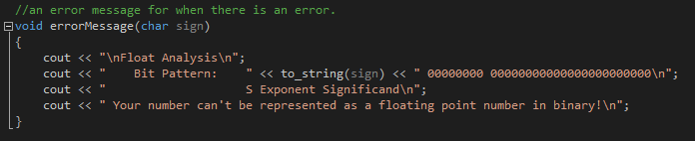

This is taking in user input and finding the decimal and whether it is positive or negative.

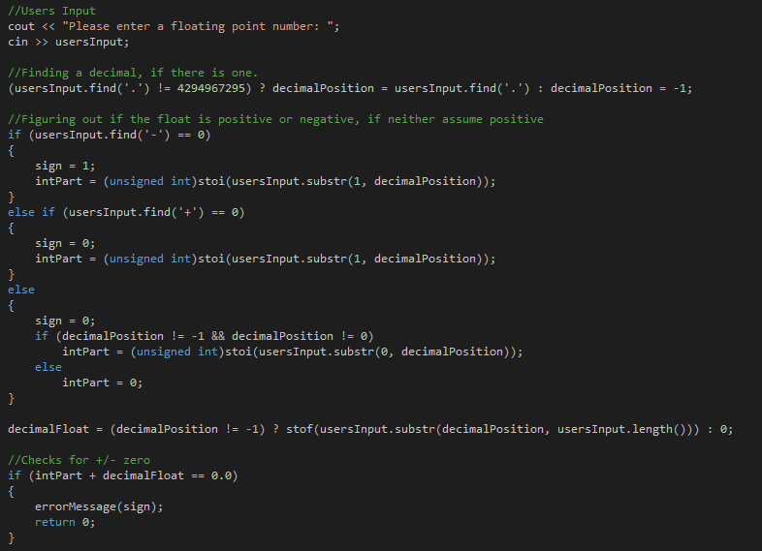

This is converting everything into the exponent and significand.

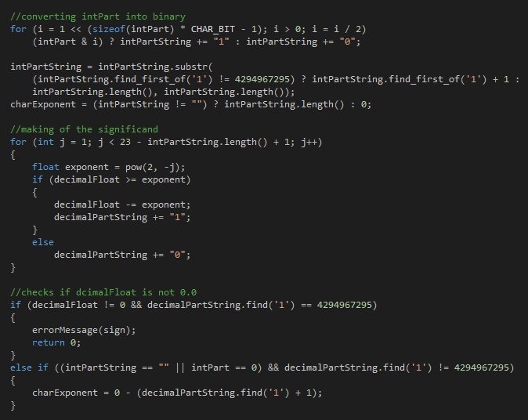

And lastly turning everything into strings and printing it out.

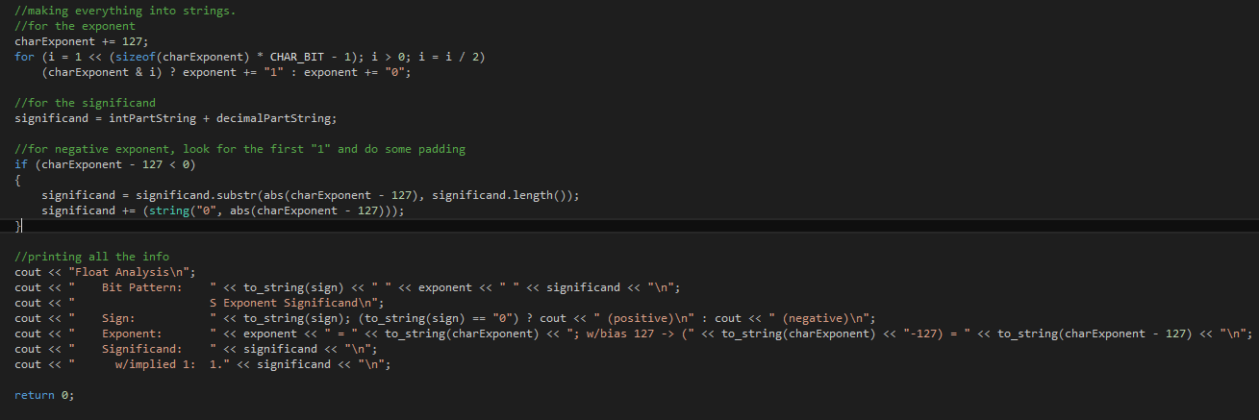

Testing:

Knowing that the bit pattern of 12.125 is 0 10000010 10000100000000000000000. And it is a positive number. We can clearly see that the output is correct in the depiction.

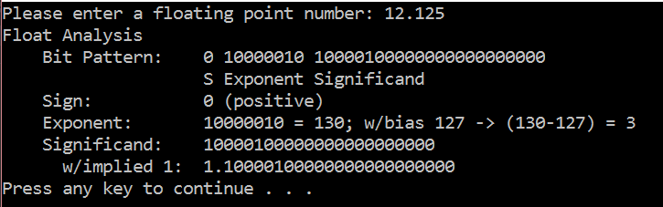

Conclusion

In conclusion this was an extremely difficult project. I relied heavily on the internet for help in programming in C++ and in the completion of this lab. However, because of that I am now more proficient in programming in C++ and doing a bit-level analysis of a floating point number. The hardest challenge I faced was doing the correct procedures in figuring out the significand of the number.